K17-3658

Maham Tariq

Section C

HTTP:

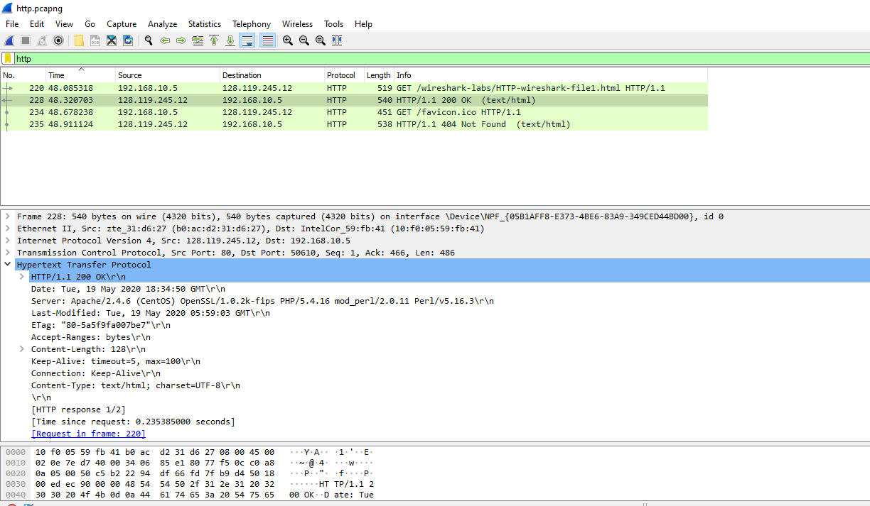

1. Both are HTTP version 1.1
2. Accept-Language: en-US,en;q=0.9\r\n
3. Computer: 192.168.10.5

Server: 128.119.245.12

1. OK
2. Last-Modified: Tue, 19 May 2020 05:59:03 GMT\r\n
3. File Data: 128 bytes
4. No